**Practices for Lesson 15: Administration in Siebel**

Practices for Lesson 5

Overview

In these practices, you will explore Siebel Server Manager and its features.

**Practices 15-1: Explore Siebel Server Manager and Features**

**Overview**

In this practice, you will explore Siebel Server Manager and its features.

Assumptions

You should have completed the Practices of Lesson 2.

Tasks

1. Go to browser and open apps URL **– https://public-ip-address:4430/siebel/app/webtools/enu.** Login as SADMIN

**Exploring Components and Component Groups in Siebel Server**

1. Navigate to **Site map**, then to **Administration – Server Configuration Page,** then to **Enterprises** as shown below. Click on **Component Group**.

**Note:** Component groups are assigned to Siebel Servers within a Siebel Enterprise Server. Both predefined and defined components groups are automatically assigned to each Siebel Server installed within an existing Siebel Enterprise Server. Component groups must be assigned to Siebel Servers before tasks can be started for the components belonging to the component group. Only make changes to the component group assignment if you want to unassign or reassign component groups to different Siebel Servers.

1. Review **Component Group** as per the section.

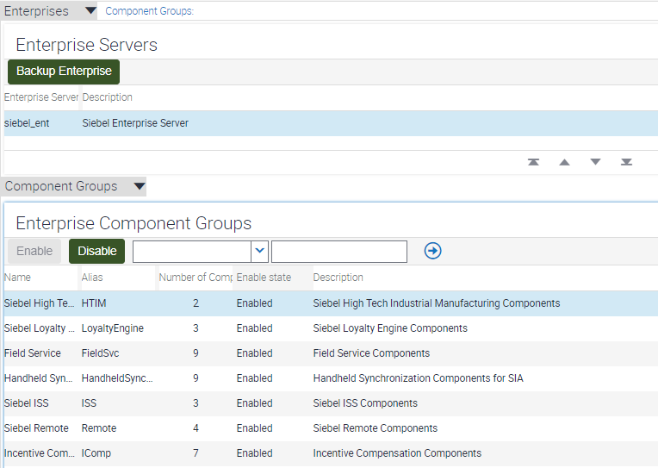

1. In the **Enterprise Component Group – Siebel Loyalty (**Alias Loyalty Engine), review the Components in Group and **identify the status** of the components.

1. In the Second Level Menu, choose **Component Definition** instead of Component Group (as we performed in Step 4).

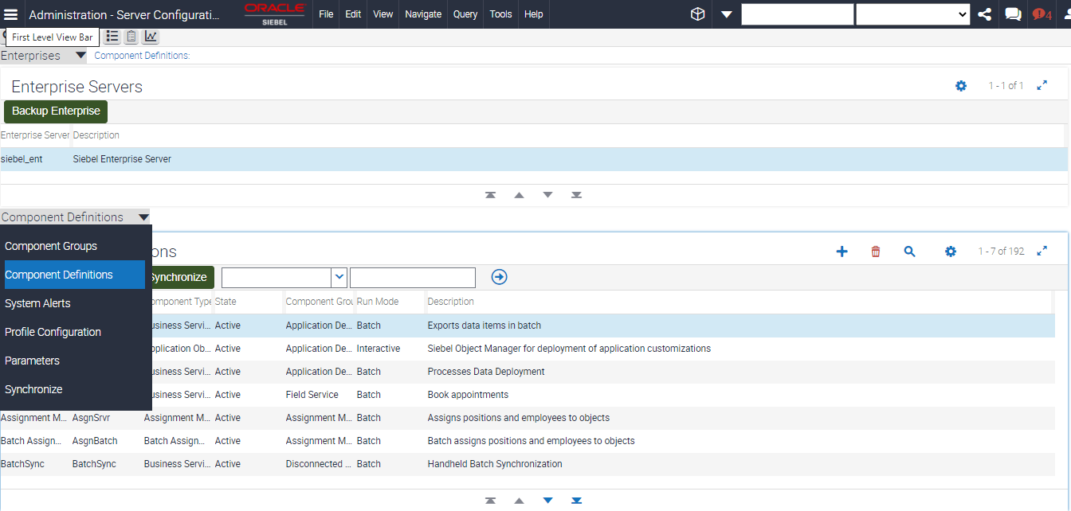

1. Now, lets filter for **Loyalty as Component group** under the 2nd level filter below. You will the definition of components are displayed.

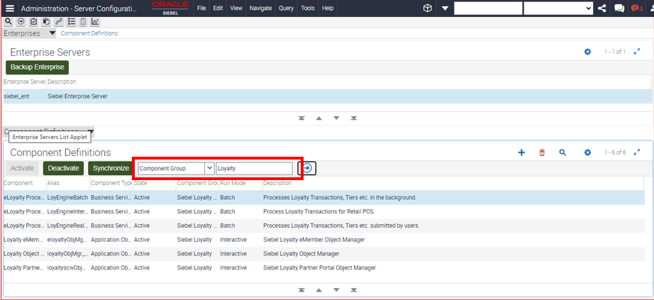

1. For each of the Component definitions selected in the second level group as in Step 4, Parameters and parameters definitions are available for information. **Scroll down** the same window to review the parameters.

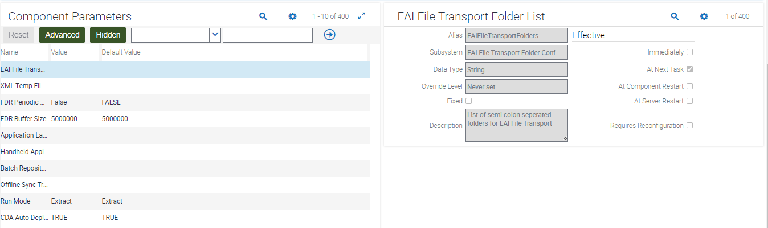

**Explore the data source profile configuration under the Enterprises in Server configuration**

1. Select Local Data Source under **Profile Configuration**. Scroll down the parameters.

1. You should be able to look at **Datasource Local docked DB filename.** Graphical user interface, text, application, email

   Description automatically generated
2. The Server Management Screen can provide information to changes to Servers and Enterprise. Visit Home – **Sitemap – Administration – Server Management – Enterprises**

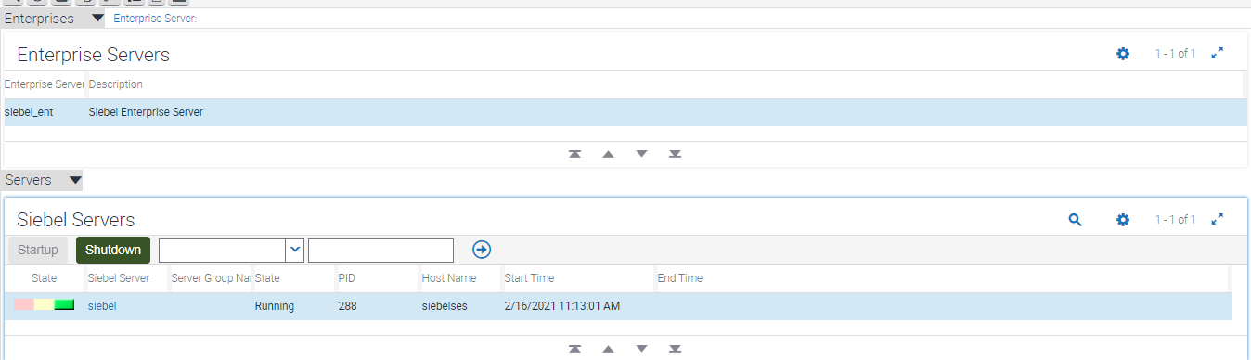

1. Let’s find the **status of EAI Object Manager (ENU)**. Is this Component **online**?



**Explore the tasks for each of the component and status of the task with timestamps**

1. Under the second level menu choose **tasks** as shown below.

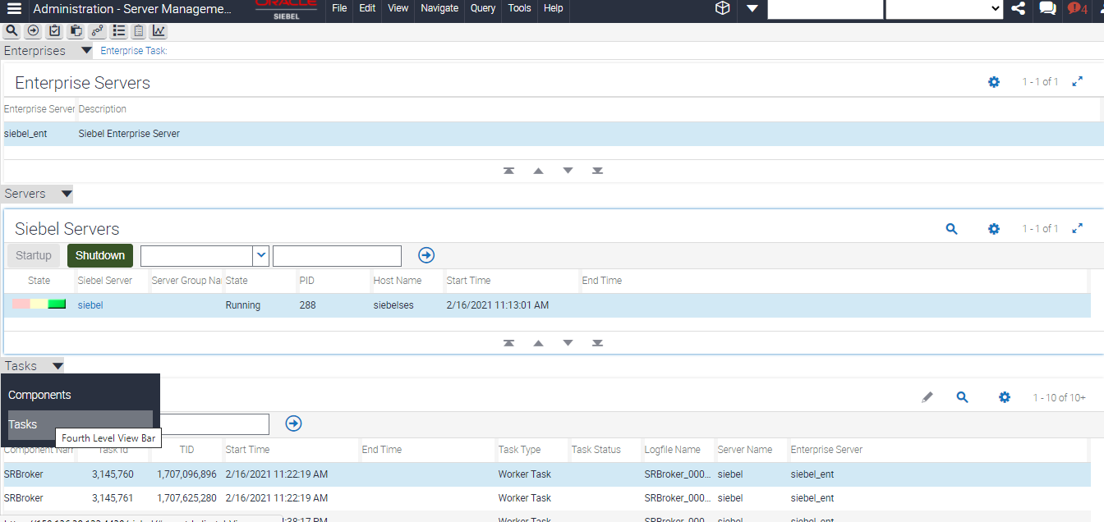

1. You will see various **SRBroker Services** running in Siebel Server. Note the timestamp and task id for the same.

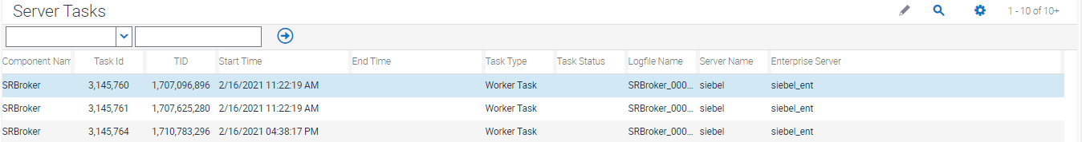

1. Now you have an option to shut down the Siebel server to maintenance. In the same page under the Enterprise, you can view the option to shut down the Siebel server.

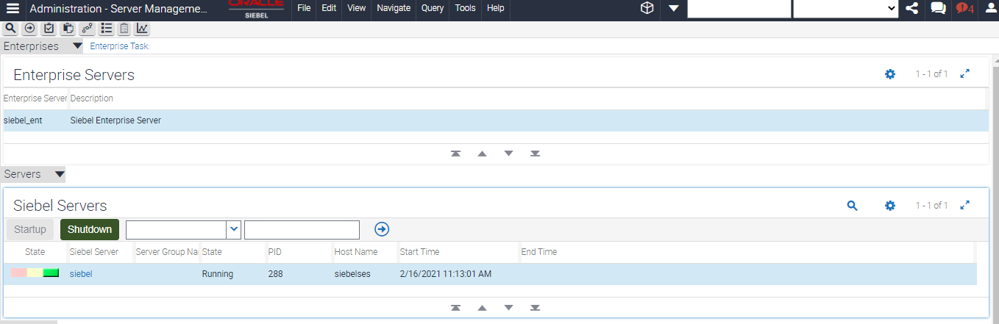

**Note:** We will not shutdown at this point.

**Practices for Lesson 15-2: Siebel Management Console**

**Overview**

In this practice, you will explore the various options available in Siebel management console for administration and configuration activities.

* Siebel Management Console URL 🡪 <http://public-ip-address:4430/siebel/smc>

Assumptions

You should have completed the Practices of Lesson 2.

Tasks

1. Open the **SMC URL** given above in the browser. Login with username as **sadmin/XXX (Password you can get it from Instructor)**

1. Review the Siebel Deployment Profile for your installation.

1. You will see an AI, Gateway Cluster, Siebel Server (4430) under Siebel Enterprise Server.
2. Click on **Profiles** link in left navigation Pane.

1. Click on **Security** profile. This provides information about the Security Adapter. Now, click on **Data Sources** Tab under the detailed page. (default)

1. You will see the database and connection properties.
2. Now, click on **Security Information** Tab on the page. The details of security adapter will be shown. It talks about DBSecAdapter (Database Security Adapter), default authentication page.

1. Click on **Enterprise** link below. This page provides details of Gateway server, authentication and Database for the Enterprise. Review the panes as below, you will see Gateway, Authentication and Security.

1. Click **Siebel Server** Profile. You will be able to look at different applications installed in the server.

1. Under the Basic Information, the details of the App are shown below.

1. The Criticality of webserver and its configuration is now available in this profile. Click on **Application Interface**.

1. Under the basic information, check for Logging (Expand Logging or Click **Logging**).

1. Now Click **on Component Definitions** available in the Siebel server.

1. The details of the component and their status will be available below. One can activate/deactivate components for your Siebel deployments accordingly. Any Updates on the components can be synchronized through the synchronize button if need be.

1. Click on **Parameters** for the component definitions chosen. The parameters and properties will be shown for the selected components.

1. Now you can see the component parameter definition, name and value is available as shown below.

1. Click on **Advanced Button** to see more parameters defined.
2. Now, choose **Component Groups** from Enterprise as shown below.

1. Now you can see which **Component Group** is visible to the Siebel Enterprise. You can add, enable and disable component group for your server.

1. You can see that the **Application Deployment Manager** is enabled. This is used for LOV (List of Values) Migration.
2. Now under **Enterprise Server**, Click **Parameters.**

1. The parameters what you see are Enterprise Parameters. You will see Parameter – **Admin Role Name** below – Like configuration parameters of Siebel Sever (Seen in Step 15), this can be overridden, deleted or modified.

**Management Link**

1. Click **Managemen**t Link in left Navigation Menu

1. Click on **Servers** as shown below.

1. You can start up and shutdown Siebel Server. In a Real case of many Siebel servers, you can start/stop specific Siebel server.

1. Now, click on the Icon for **Deployment** Properties to view your configuration.

1. Click on Management Link on left navigation menu to come back to menu.

**Review the Log information from SMC through Management link.**

1. Click on **Log** from the Server.

1. You will get the information for Server Information Log.

1. Click on **Sessions** from Enterprise. This provides Session Logs

1. The Current Running/Closed Session History is available . It can be **refreshed** if needed.

1. Click on **Tasks** Log for Enterprise Server.

1. Check the Task Log, you will see status of each of the task with timestamp.

1. Click on **Settings** from Left Navigation Pane. The Settings information will display the Gateway Log for the information.

1. In the same Page, you will see a Gateway Safe Mode Credential, New Feature.

**Note:** Safe mode for Siebel Management Console, available as of Siebel CRM 19.11 Update, addresses the problem where an administrator cannot log in to Siebel Management Console because the back-end server for the authentication system, such as a database or an LDAP server, is unavailable.